TWIN RIVERS PARISH COUNCIL

THE ORDINARY MEETING OF THE COUNCIL WILL BE HELD
IN THE VILLAGE HALL ON TUESDAY 13th MAY 2025 After the annual parish meeting which will commence at 7pm.

You are summoned to attend.
Public Forum 7.30-7. 40pm.Any members of the public attending the meeting may be given (at the chairman’s discretion) a combined 10-minute time slot to address councillors on any items of concern or interest. After this period the public are welcome to stay for the full parish council meeting but CANNOT speak nor offer advice/opinion on any matter. This public participation is NOT part of the parish council meeting and as such there are no rights to record this part of the meeting in any way.

ANNUAL GENERAL MEETING
Election of Chair
Election of Vice Chair
Meetings in the year

AGENDA

Apologies for absence.

Minutes

The minutes of the last meeting held on 8th April 2025 have been circulated to all councillors prior to the meeting.

Declarations of Interest.

Declaration of Interest – The parish councils (Model Code of Conduct Order 2011). To record any declarations of interest by any member in respect of items on this agenda). Members declaring interests should identify the agenda item and type of interest being declared.

Financial Matters

To be updated at the meeting

Current account £

Business reserve
Cow lane Current account -

Clerks wages

ONGOING ISSUES

Cow Lane

Ousefleet Community Hall update.

Health and Safety Issues.

PLANNING

COUNCILLOR ISSUES
One co options exist. Advertised on the website, noticeboards and in the Goole Times.

Bridleway

Noticeboard.

Planters

National grid

Insurance

Whitgift lighthouse

Speeding

Carbon capture pipeline

Newsletter

Planters

Phone Box

Sim card payments

Grants

Cenotaph

CORRESPONDENCE

WARD COUNCILLOR’S REPORTS

ITEMS FOR THE NEXT AGENDA

Date and place of the next meeting

Tuesday 10th June 2025.

Signed

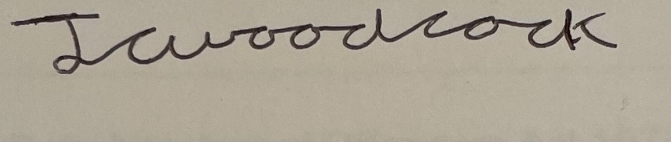
James Woodcock- Clerk and RFO

